**Rotterdam School of Management (RSM), Erasmus University**

* **Learning from Big Data 2025 –**

**ZOZO DATASET**

A/B test of two multi-armed bandit policies in a large-scale fashion e-commerce platform, ZOZOTOWN (https://zozo.jp/). This is especially suitable for evaluating offline evaluation, which attempts to predict the counterfactual performance of hypothetical algorithms using data generated by a different algorithm.

Each row representing a user impression with some feature values, selected items as actions, true propensity scores, and click indicators as an outcome.

This is especially suitable for evaluating off-policy evaluation, which attempts to predict the counterfactual performance of hypothetical algorithms using data generated by a different algorithm.

**Data dump 1:**

I first made available data for 10, 20 and 80 items belonging to a campaign that does not differentiate between men and women. All this was under a random policy, which means items were selected at random. These were the three files:

* **zozo_Nocontext_10items:**

n= 172,400 rows

Variables: timestamp, item_id, position, click, propensity score

* **zozo_Context_20items:**

n= 345,469 rows

Variables: timestamp, item_id, position, click, propensity score, user_feature_0, user_feature_1, user_feature_2, user_feature_3

* **zozo_Context_80items:**

n= 1+ million rows

Variables: timestamp, item_id, position, click, propensity score, user_feature_0, user_feature_1, user_feature_2, user_feature_3

**First row of data:**



**Data dump 2: Towards non-random**

Here is the histogram of the items served in the original entire non-random data, which has more than 12 million observations.

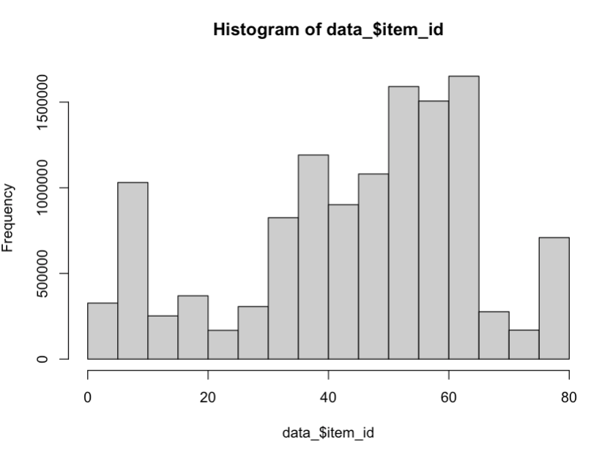

Because the data is so large, I am giving you a subset of it with the same number of items and rows than the RCT data you already have:

* **zozo_bts_Nocontext_10items:**

n= 172,400 rows

Variables: timestamp, item_id, position, click, propensity score, user_feature_0, user_feature_1, user_feature_2, user_feature_3

* **zozo_bts_Context_20items:**

n= 345,469 rows

Variables: timestamp, item_id, position, click, propensity score, user_feature_0, user_feature_1, user_feature_2, user_feature_3